In order to enable DHCP relay functionality for the LTE modem of this device, there are 2 requirements:

1. Upgrade the AR software to V200R008C50SPC500

   It is also recommended to install the latest patch

2. Upgrade the LTE modem firmware to version 11.617.07.10.00

This firmware file is not available on our support website because it is released by the vendor of the LTE chip.

You can download it from this internal link: <https://onebox.huawei.com/p/5ac33cb2e3b10e02452ea263ee8e60d1>

For the upgrade, first transfer the file to the device, then execute the command below

<Huawei> system-view

[Huawei] diagnose

[Huawei-diagnose] module-upgrade slot 0 module 0 flash:/ME909_UPDATE_11.617.07.10.00.FWL

The upgrade process will take some time, and you can check the result using the command display cellular 0/0/0 all

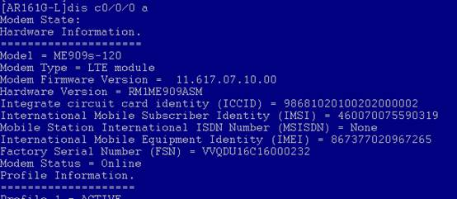

tftp den IOS atmak için gerekli komut

<ENGININ_CIHAZI>tftp 192.168.1.12 get ME909_UPDATE_11.617.07.10.00.FWL

Bittikten sonar aşağıdaki komut atılacak

Repeat the process for Cellular0/0/1

[Huawei-diagnose] module-upgrade slot 0 module 0 flash:/ME909_UPDATE_11.617.07.10.00.FWL

The upgrade process will take some time, and you can check the result using the command

Yükseltme işlemi biraz zaman alacak ve sonucu kontrol ederek kontrol edebilirsiniz.

display cellular 0/0/0 all

sonrasında dis cel 0/0/0 a yapılarak devre kontrl edilir