AR109GW-L device upgrade guidance

Upgrade steps
USB-based Deployment Process：
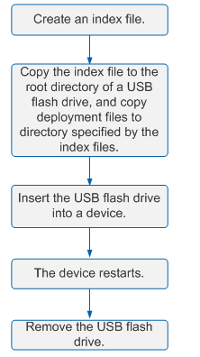
- The index file(USB_AR.ini) is made below. Put it together with software version(AR100-V200R008C50SPC500.cc) and LTE firmware(ME909_UPDATE_11.617.07.10.00.FWL) into the USB under the root directory
- Power on the router. Insert the USB flash into the devie, The system detects the USB flash drive
- Observe the USB indicator on the device to determine the progress of USB-based deployment
- Steady green: The USB-based deployment succeeded.
- Blinking green: The system USB-based deployment is ongoing.
- Steady red: USB-based deployment has failed.。
- When the process is finished, plug out the USB flash. Then make sure whether the version is new version.
Using a terminal tool such like putty to login the router and check whether the version is upgraded by using the following commands.
<huawei>sys
[huawei]diagnose
[Huawei-diagnose]vrbd
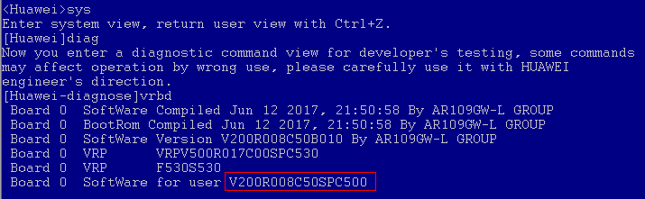
- Then let’s check whether the firmware version is existed in router’s flash
<huawei>dir ME909*
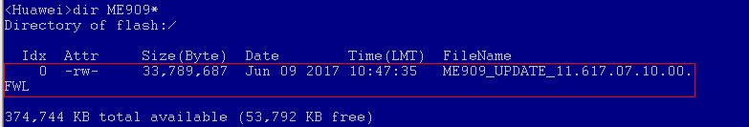
- Upgrade the firmware version manually. Customer can do this when they deploy the router on network
Input the following commands and wait for the upgrade:
<huawei>sys
[huawei]diag
[Huawei-diagnose]module-upgrade slot 0 module 0 flash:/ME909_UPDATE_11.617.07.10.00.FWL
y
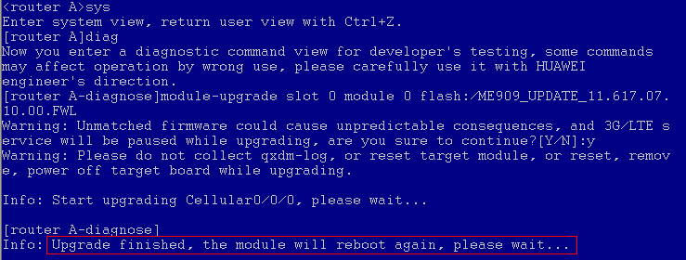
- Check whether the firmware version upgrade successfully
[huawei]dis cel 0/0/0 hardware
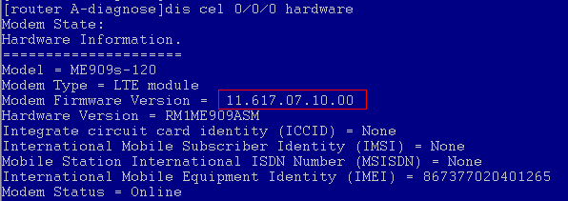
If the Modem Firmware version is 11.617.07.10.00, means firmware upgrade successfully。

Notice
- Don’t power off during the upgrade process
- Don’t plug out USB flash during the upgrade process

